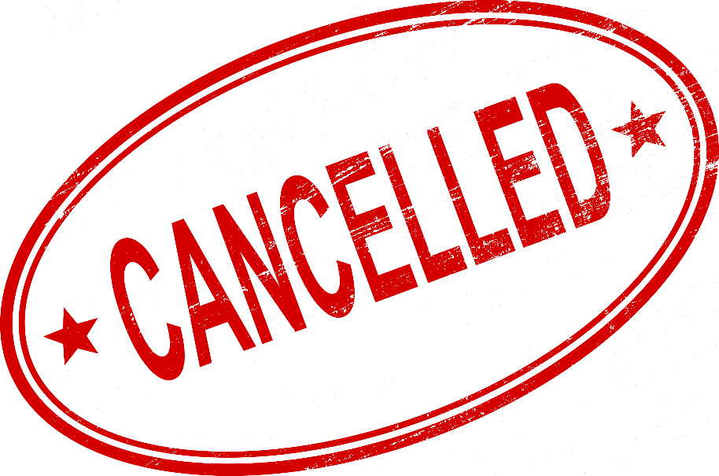

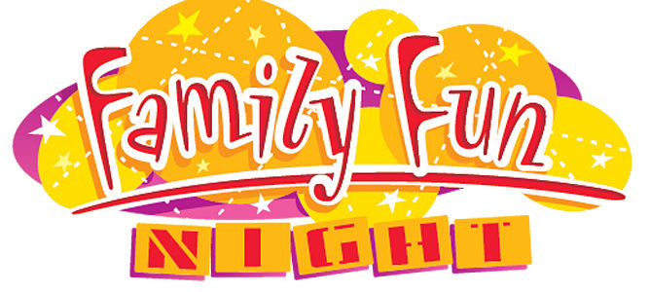

Due to social distancing guidelines all Coulee Connections’ scheduled family Fun Nights are cancelled. If this changes, we will let you know. Thank you for your understanding.

Sincerely,
Coulee Connections Team

